Book

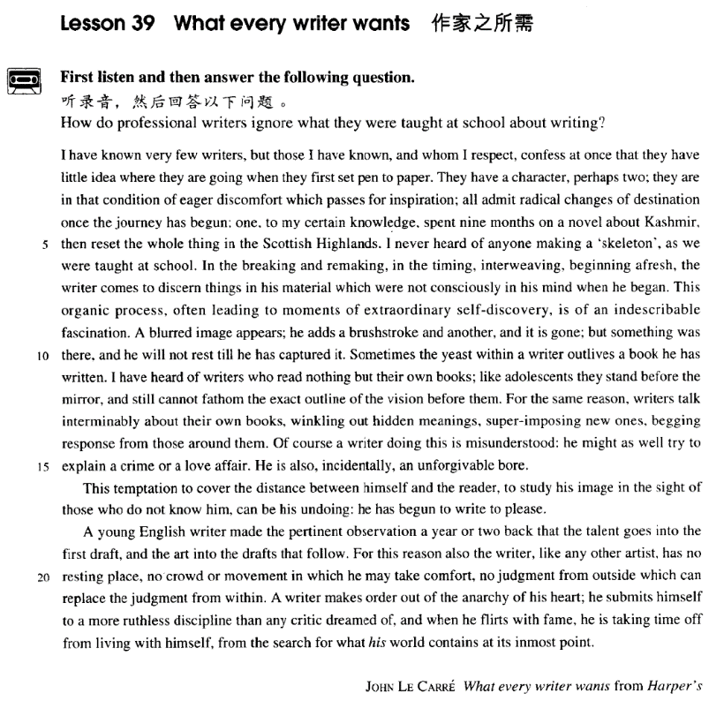

课文

I have known very few writers, but those I have known and whom I respect, confess at once that they have little idea where they are going when they first set pen to paper.

我的认识的作家寥寥无几，然而凡是我所认识和尊敬的作家，都立即承认在他们动笔时，不清楚要写什么，怎么写。

They have a character, perhaps two; they are in that condition of eager discomfort which passes for inspiration all admit radical changes of destination once the journey has begun;

他们心中只在一个或两个角色。他们处于急切不安的状态，而被当作是灵感。他们无不承认，一旦“旅程”开始，“目的地”常有急剧的变化。

one, to my certain knowledge, spent nine months on a novel about Kashmir, then reset the whole thing in the Scottish Highlands.

据我所知，有位作家花了9个月的时间写了一部关克什米尔的小说，后来却把整个故事背景换成了苏格兰高地。

I never heard of anyone making a 'skeleton', as we were taught at school.

我从未听说过任何一位作家像我们在学校那样，

In the breaking and remaking, in the timing interweaving, beginning afresh, the writer comes to discern things in his material which were not consciously in his mind when he began.

动笔前先列什么提纲。作家在剪裁修改、构思时间、穿插情节、以至从头重写的过程中，会领悟到素材中很多东西是他刚动笔时所未意识到的。

This organic process, often leading to moments of extraordinary self-discovery, is of an indescribable fascination.

这种有机的加工过程往往达到不寻常自我发现的境界，具有难以言表的构思魅力。

A blurred image appears; he adds a brushstroke and another and it is gone but something was there, and he will not rest till he has captured it.

一个朦胧的形象出现在作家的脑海里，他左添一笔，右添一笔，形象反而消逝了；可是，好像还有什么东西存在着，不把它捕捉到，作家是不会罢休的。

Sometimes the yeast within a writer outlives a book he has written.

有时，一个作家一本书写完了，但兴奋仍不消散。

I have heard of writers who read nothing but their own books;

我听说一些作家，除了自己的书外，别的书一概不读，

like adolescents they stand before the mirror, and still cannot fathom the exact outline of the vision before them.

犹如希腊神话中那位漂亮的少年，站在镜前，不能辨认自身的真面目。

For the same reason, writers talk interminably about their own books, winkling out hidden meanings, super-imposing new ones, begging response from those around them.

由于这个原因，作家喋喋不休地谈论自己的书，挖掘其隐晦的含义，询问周围人的反应。

Of course a writer doing this is misunderstood: he might as well try to explain a crime or a love affair.

作家如此行事当然被人误解。他还不如给人讲一个犯罪案件或一个恋爱故事。

He is also, incidentally, an unforgivable bore.

顺便说一句，他也是个不可饶恕的令人厌烦的人。

This temptation to cover the distance between himself and the reader,

这种企图消除自己和读者之间距离的作法，

to study his image in the sight of those who do not know him, can be his undoing: he has begun to write to please.

企图用不了解自己的人的观点来研究自己塑造的形象的作法，会导致作家的毁灭，因为他已经开始为取悦他人而写作了。

A young English writer made the pertinent observation a year or two back that the talent goes into the first draft, and the art into the drafts that follow.

一两年前，一位年轻的英国作家发表了中肯的看法。他说，初稿是才华，以后各稿是艺术。

For this reason also the writer, like any other artist, has no resting place, no crowd or movement in which he may take comfort, no judgment from outside which can replace the judgment from within.

也是由于这个原因，作家同任何艺术家一样，找不到可休息的场所，找不到伙伴和活动使自己得到安逸。任何局外人的判断也比不上他内心的正确判断。

A writer makes order out of the anarchy of his heart;

一旦作家从内心的紊乱中理出头绪，

he submits himself to a more ruthless discipline than any critic dreamed of,

就应该按任何评论家想像不到的无情规范约束自己写作；

and when he flirts with fame, he is taking time off from living with himself, from the search for what his world contains at its inmost point.

当他沽名钓誉时，他就脱离了自我生活，脱离了对自己灵魂最深处世界的探索。

词汇讲解

Lesson 39 What every writer wants

confess [kən'fes]

v. 向神父忏悔；

坦白罪行；承认糗事

He knelt and confessed his sin. The prisoner confessed his crime. confess that … / to doing

He confessed that he did not understand financial matters at all. He confessed to being a drug addict.

admit / acknowledge

sth. doing sth. that …

concede

I conceded that I had made a number of errors. avow

Homosexuality is rarely avowed. profess

Many corrupt officials profess not to be interested in money. assert

She asserted her innocence. allege

The defense alleges that Jones was beaten up while in police custody.

Was the philosopher who refused to look through Galileo's telescope more culpable than those who alleged that the spiral nebulae observed with Lord Rosse's great telescope in the eighteen-forties were scratches left by the grinder?

One allegation often made is that noise produces mental illness. inspiration

[7ɪnspə'reɪʃn]

n. 灵感

Poets often get their inspiration from nature. inspire

The Muse does not inspire all poets equally. perspiration

Genius is one percent inspiration and ninety-nine percent perspiration.

— Thomas Edison

perspire

He was perspiring profusely after the game. aspiration

I have no aspiration for fame. aspire

aspire to success

aspire to succeed respiration artificial respiration respire

respire deeply interweave [7ɪntə'wi:v]

v. 交织interweave interwove

interwoven

Your destiny is interwoven with mine.

The two themes are inextricably interwoven in the book. weave

the Herd-boy and the Weaving-girl

“inter” = between, among intervene

intercede intercept interpose intersperse

interstellar interstellar travel interpersonal

interpersonal relationships / skills

interactive interactive teaching interdependent

the increasingly interdependent global economy afresh [ə'freʃ]

adv. 重新，重来一遍

She tore up the letter and started afresh. once again

once more over again anew

They made people look at familiar objects as if for the first time, savoring afresh their dimensions, pondering anew their significance.

So let us begin anew—remembering on both sides that civility is not a sign of weakness, and sincerity is always subject to proof. Let us never negotiate out of fear, but let us never fear to negotiate.

— John F. Kennedy

blur [blɜ:(r)]

v. （使）模糊不清

Tears blurred her eyes.

Her eyes blurred with tears.

The new commercial blurs the line between art and advertising. blurred

a blurred photograph slur

slurred indistinct

an indistinct shape / sound / recollection

vague

a vague figure a vague answer hazy

the hazy sky

a hazy view of the mountains hazy recollections

fuzzy

Is the picture always fuzzy on your TV?

You can pick up a lot of stations on the car radio, but the sound is usually

a bit fuzzy. ambiguous

The wording of the agreement is ambiguous. yeast [ji:st]

n. 酵母（菌）；激动，骚动

Political agitators are the yeast of revolution. ferment

The whole country was in a state of political ferment. catalyst

They hope his election will act as a catalyst for reform. pertinent ['pɜ:tɪnənt]

adj. 中肯的，切题的

pertinent adj. directly relating to sth. that is considered or discussed He made some pertinent comments.

He asked some pertinent questions. be pertinent to sth.

That is not pertinent to the topic we are discussing. relevant

be relevant to sth.

Relevant work experience is required for the position.

the relevant authorities

I don’t think his remarks are relevant to our discussion. irrelevant

irrelevant details be irrelevant to sth.

The testimony is irrelevant to the case. permanent

a permanent job prominent

a prominent political figure provident

He is provident of his money. flirt [flɜ:t]

v. 调情；不经意地对待

flirt with sb.

She accused him of flirting with other women. flirt with sth.

I’ve been flirting with the idea of buying a house. The bullfighters are flirting with death.

Climbers enjoy flirting with danger. He enjoys flirting with fame.

inmost ['ɪnməʊst]

adj. 最秘密的，最核心的

inmost = innermost

express one’s innermost feelings reveal a company’s innermost secrets outermost

Pluto is the outermost known planet. uppermost

The rain spattered on the uppermost leaves. be uppermost in one’s mind

Although I’m here in Beijing, my family back in my hometown is always uppermost in my mind.

nethermost foremost

hindmost

leftmost rightmost

easternmost southernmost

westernmost northernmost

internal internal organs internal affairs

external

for external use only external relations interior

the interior walls exterior

the exterior walls intrinsic

intrinsic nature intrinsic value extrinsic

a combination of intrinsic and extrinsic factors incoming

incoming calls

an incoming passenger train outgoing

an outgoing train an outgoing ship

an outgoing personality

I have known very few writers, but those I have known, and whom I

respect, confess at once that they have little idea where they are going

*when they first set pen to paper*.

I have no idea / don’t know what to do next.

Do you have any idea / Do you know how fast you drive? set pen to paper

set fire to sth.

set foot in / on some place

She swore she would never set foot in his house again. I’ve never set foot on Taiwan.

set eyes on sb./sth.

I loved that house from the moment I set eyes on it. set one’s heart on sth.

His father bought him the bike he had set his heart on. lose one’s heart to sb.

They have a character, perhaps two; they are in that condition of eager discomfort which passes for inspiration; all admit radical changes of destination once the journey has begun; one, *to my certain knowledge*, spent nine months on a novel about Kashmir, then reset the whole thing in the Scottish Highlands.

pass for / as …: wrongly accepted as being a particular type of person or thing

She is nearly fifty, but she could pass for thirty.

With her hair cut so short, she often passes for a boy. mistake … for …

I often mistake her for her mother on the phone.

You mistook friendship for love. radical / fundamental changes

a radical / fundamental error

We also make the fundamental error of announcing our resolutions to everybody so that we look even more foolish when we slip back into our bad old ways.

radical political views

a radical left-wing group conservative

reactionary destiny

We’re masters of our own destiny. destined

He is destined to be a musician. to my (certain) knowledge

to the best of my knowledge as far as I know / am aware

as far as I’m concerned

As far as I’m concerned, feng shui is a load of rubbish. with / without one’s knowledge

He did it without my knowledge.

I had no knowledge of the incident.

He denied all knowledge of the robbery. be set in …

The novel / movie is set in 18th century New England.

I never heard of anyone making a 'skeleton', *as we were taught at school*. In the breaking and remaking, in the timing, interweaving, beginning

afresh, the writer comes to discern things *in his material* which were not consciously in his mind when he began.

come to so sth: to do sth. by chance, without planning or intending to do it

A body came to be found under the bridge.

Future historians will be in a unique position when they come to record the history of our own times.

He soon made a name for himself and came to be known to the Italians as Giovanni Acuto.

This organic process, often leading to moments of extraordinary self-discovery, is of an indescribable fascination.

organic adj. made of related parts; arranged as a system 有机的有组织

的，有系统的

City planning treats the city as an organic whole.

self-discovery n. the process of achieving understanding or knowledge of oneself

The process of writing a novel is a process of searching the writer’s

innermost soul.

… is of an indescribable fascination

= … is indescribably fascinating

A blurred image appears; he adds a brushstroke and another, and it is gone; but something was there, and he will not rest till he has captured it. Sometimes the yeast within a writer outlives a book he has written. outlive

I’m sure he will outlive many of us. outwit / outfox

The burglar outwitted / outfoxed the police and got away. outrun

He easily outran all of us.

His ambition outran his ability. outnumber

The boys outnumber the girls. outweigh

He outweighs me by 40 pounds.

The advantages outweigh disadvantages.

I have heard of writers who read nothing but their own books; *like*

*adolescents* they stand before the mirror, and still cannot fathom the exact outline *of the vision before them*.

William S. hart was, perhaps, the greatest of all Western stars, for unlike

Gary Cooper and John Wayne he appeared in nothing but Westerns. Narcissus: In Greek mythology, Narcissus is a handsome youth, who pined away in love for his own image in a pool of water and was transformed into the flower that bears his name.

narcissus daffodil narcissist narcissism

For the same reason, writers talk interminably about their own books,

*winkling out hidden meanings*, *super-imposing new ones*, *begging*

*response from those around them*. superimpose sth. on / upon …

Since the sea covers the greater part of the earth's surface, it is quite reasonable to regard the sea floor as the basic form of the crust of the earth, with, superimposed upon it, the continents, together with the islands and other features of the oceans.

Of course a writer doing this is misunderstood: he might as well try to explain a crime or a love affair.

might as well / may as well do sth. used for saying that it might be a good idea to do something although it is not essential 不妨，倒不如……

You might as well take the job if you can’t find a better one at the

moment.

love affair: a romantic sexual relationship especially one between people who are not married to each other

lowbrow

lowbrow literature / novels

highbrow

highbrow classical music

incidentally adv. by the way; by the bye

incidental incidental expenses

incidental music for the movie accidental

the accidental-noble outlaw unforgivable

inexcusable unpardonable

bore n. someone who is boring, esp. because they talk too much about themselves or about things that do not interest you 唠叨乏味的人

The bore bores me to death.

This temptation to cover the distance *between himself and the reader*, to study his image *in the sight of those who do not know him*, can be his undoing: he has begun to write to please.

the temptation to please the reader / cater to the reader

Lowbrow journals cater to people’s love of scandal. in sb’s sight

in the sight of sb in sb’s eyes

in the eyes of sb

… to study his image from the perspective of those who do not know him.

be sb’s undoing

be the undoing of sb. Conceit was his undoing.

Greed is the undoing of many a businessman.

One night, however, feeling cold and lonely, I went downstairs and sat in front of the television pretending to read. That proved to be my undoing, for I soon got back to my old bad habit of dozing off in front of the screen.

A young English writer made the pertinent observation a year or two back that the talent goes into the first draft, and the art into the drafts *that*

*follow*.

make an observation: make a comment / remark

His wife died a couple of years back. The house was built back in 1949.

For this reason also the writer, *like any other artist*, has no resting place, no crowd or movement in which he may take comfort, no judgment *from*

*outside* which can replace the judgment *from within*. take comfort in …

take pleasure in …

The boys take pleasure in practical jokes. take pride in …

take interest in …

Even people who take no interest in art cannot have failed to notice examples of modern sculpture on display in public places.

Kidnappers are rarely interested in animals, but they recently took considerable interest in Mrs. Eleanor Ramsay's cat.

take refuge in …

Residents took refuge in the local church. take notice of …

take pity on …

I took pity on the beggar and gave him some change. replace sth.

Before they were replaced by steamships, sailing vessels like the Cutty Sark were used to carry tea from China and wool from Australia. substitute A for B

You can substitute chicken for beef if you don’t like red meat.

It is only in the study of man himself that the major social sciences have substituted the study of one local variation, that of Western civilization, (for the study of custom of all human beings).

A fortress can be easily broken from within.

A writer makes order out of the anarchy of his heart; he submits himself to a more ruthless discipline than any critic dreamed of, and *when he flirts with fame*, he is taking time off *from living with himself*, *from the search*

*for what his world contains at its inmost point*.

in ascending / descending / chronological / alphabetical / reverse order in order of priority / precedence

submit (oneself) to …

They are constantly after the turtles, who peacefully submit to all sorts of indignities.

He submitted himself to a search by the guards. bow / yield / succumb to …

ruthless adj. merciless 无情的，无怜悯心的

take time off from …

I have to take time off from work / school to go to the dentist. Do you still live there?

Oh yes, yes. My husband’s there now. He couldn't take time off to come to New York with me.

take a day off

take the afternoon off

take time off from daily routine annual leave

paid leave

She is on leave.

She is on sick leave.

She is on maternity leave. He is on paternity leave. get away: have a holiday

get away from it all: have a thoroughly relaxing holiday

That the equipment of modern camping becomes yearly more sophisticated is an entertaining paradox for the cynic, a brighter promise for the hopeful traveler who has sworn to get away from it all.